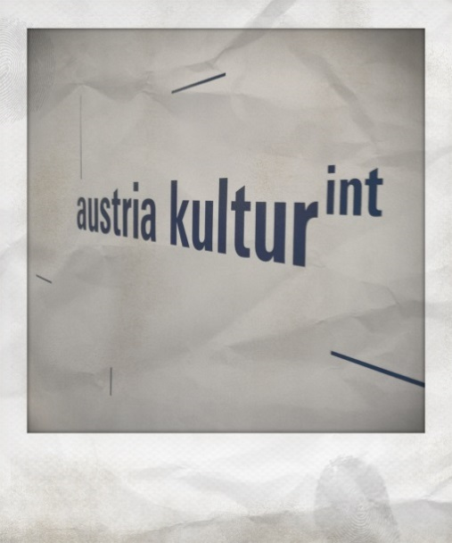

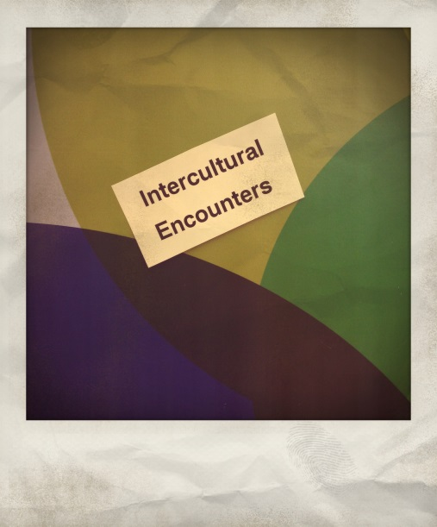
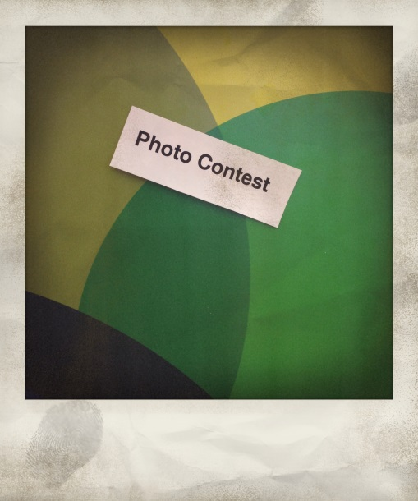



Photo Contest

„Intercultural Encounters“

Send us your photo!

Background Information
Intercultural Dialogue depicts a significant and successful instrument in the exchange between cultures and religions. In order to further strengthen the concept of dialogue, the Austrian Foreign Ministry (FMeiA) founded the Task Force “Dialogue of Cultures” in 2007, further consolidating efforts and actively engaging in multilateral and bilateral initiatives in the field of intercultural and interreligious dialogue. The Task Force’s projects are characterized by continuous cooperation with civil society, composed of organizations and experts who dedicate their efforts to the promotion and advancement of dialogue as an indispensable concept.

This photo contest - entitled „Intercultural Encounters“ - describes the Task Force’s newest initiative and aims to capture impressions, encounters, and experiences in the field of dialogue in form of pictures. The project further serves as an attempt to illustrate the many facets of dialogue as well as the diversity in opinion, interpretation, and understanding of the photographers in respect to the presented concept. A central aspect is “travelling”, which presents an imperative tool to approach and explore different cultures and religions.

Award

Among all received photos, the most impressive and meaningful ones will be selected for the award by our jury. The best photos will become part of an exhibition that will travel through our Austrian Cultural Fora abroad and thus further promote the concept of intercultural and interreligious dialogue through your demonstrations. The three winners will be awarded with a camera by Lomo (http://www.lomography.com).

Criteria
- Between the ages 18 und 35;
- The photo must be taken by you:
- Please provide the following Information in addition to your photo
  - Titel
  - Place and Date of recording
  - Short Description – max. 500 characters (incl. blanks)

Contact
Please submit your picture no later than February 28th, 2014, including your full coordinates (Name, Address, Date of Birth, and Phone Number) to dialog@bmeia.gv.at.

Terms and Conditions

Copy Rights: The photographer must be the sole author and owner of the copyright of photos submitted to this contest. In case of the portrayal of third parties, the author must also confirm to have the necessary permission from people who may appear in the photo, that no personal rights are in breach and that these persons are in agreement with publication of the respective visualizations.

Usage Rights: By entering this contest, the photographer agrees that the image(s) you submitted may be used and/or publicized by the Austrian Foreign Ministry (FMeiA) for the purpose of this contest, media coverage in relation to this contest or exhibitions. The author confirms that usage rights of third parties displayed on the images are available to him/her.

Exclusion: Offensive, violent, racist, or discriminatory photos, as well as this that to not exhibit a clear context to the presented concept of dialogue, will not be accepted and deleted.

Quality of Image: Photo resolution must depict a minimum of 8 megapixels. The picture should be submitted in highest quality available in a JPG format. Please note that the resolution of the picture will feed into the final decision of the jury.

Personal Information: Personal information of participants will be considered in confidence and will not be shared with third parties. By entering this contest, the author agrees that name, location and the project description will be published together with the respective photo. In case of selection, the participant agrees to the publication of name and location in relevant media and exhibitions is acceptable.

Supported by


